**Automation Testing of Zappos Product/Application**

# A PROJECT REPORT

***Submitted by***

|  |  |
| --- | --- |
| **Raunak Singh**  **Abhiram Vasadi** | **22BCS16382**  **22BCS15778** |

*In partial fulfilment of the award of the degree:*

# BACHELORS OF ENGINEERING

**IN**

COMPUTER SCIENCE



**CHANDIGARH UNIVERSITY**

**April 2025**



# BONAFIDE CERTIFICATE

This is to certify that the project report titled **" Automation Testing of Zappos Product/Application "** is a bonafide record of the work done by **Raunak Singh (UID:**

**22BCS16382), Abhiram Vasadi (UID: 22BCS15778)** in partial fulfilment of the requirements for the award of the Bachelor of Engineering in Computer Science and Engineering (BE-CSE) at Chandigarh University.

This project report embodies the original work done by the candidates under the supervision and guidance of Ms. Richa Dhiman. The work presented in this report has not been submitted elsewhere for the award of any degree or diploma.

Assistant Professor

Department of Computer Science and Engineering

Chandigarh University

Date: [18-04-2025]

**ACKNOWLEDGEMENT**

We would like to express our sincere gratitude to all those who contributed to the successful completion of this project titled "Automation Testing of Zappos Product/Application."

First and foremost, we would like to thank Arshdeep Grover, Assistant Professor, Department of Computer Science and Engineering, Chandigarh University, for his invaluable guidance, constant support, and encouragement throughout the duration of this project. His expertise and insights have been instrumental in shaping our understanding and approach towards the project.

We extend our heartfelt appreciation to the faculty members of the Computer Science and Engineering Department for their valuable feedback and suggestions, which significantly enriched our project.

We are also thankful to our peers and friends for their encouragement and support during the various stages of this project. Their constructive criticism and discussions have been instrumental in refining our ideas and methodologies.

Last but not least, we would like to express our gratitude to our families for their unwavering support, understanding, and encouragement throughout this endeavour.

Raunak Singh 22BCS16382

Abhiram Vasadi 22BCS15778

Bachelor of Engineering in Computer Science and Engineering

Chandigarh University

[18-04-2025]

**TABLE OF CONTENTS**

**CHAPTER 1. INTRODUCTION…………………………………..…… …………………..6-8**

1.1 Identification of Client & Need

1.2 Relevant Contemporary Issues

1.3 Problem Identification

1.4 Task Identification

1.5 Timeline

1.6 Organization of the Report

**CHAPTER 2. LITRATURE SURVEY ..................................................................................8-10**

2.1 Timeline of the Reported Problem

2.2 Bibliometric Analysis

2.3 Proposed Solutions by Different Researchers

2.4 Summary Linking Literature Review with the Project

2.5 Problem Definition, Goals, and Objectives

**CHAPTER 3. DESIGN FLOW/PROCESS……………………………………………….11-17**

3.1 Concept Generation, Evaluation & Selection of Specifications/Features

3.2 Design Constraints

3.3 Analysis and Feature Finalization Subject to Constraints

3.4 Design Flow

**CHAPTER 4. RESULTS ANALYSIS AND VALIDATION……………………………..18-19**

4.1 Implementation of Design Using Modern Engineering Tools

4.2 Analysis, Design Drawings/Schematics/Solid Models

4.3 Report Preparation

4.4 Project Management and Communication

4.5 Testing/Characterization/Interpretation/Data Validation

**CHAPTER 5. CONCLUSION AND FUTURE WORK……………………………….20-21**

5.1 Conclusion

5.2 Deviation from Expected Results

5.3 Future Work

**LIST OF FIGURES…………………………………………………………………….22-23**

**REFRENCES…………………………………………………………………………........24**

**CHAPTER 1.**  **INTRODUCTION**

In the contemporary digital landscape, e-commerce stands as a pivotal avenue for businesses to engage with consumers and propel sales. As online shopping platforms continue to gain prominence, enterprises encounter a blend of opportunities and hurdles in establishing a robust online footprint. Within this dynamic environment, our project sets its sights on the automation testing of the Zappos Product/Application, delving into the intricacies of addressing the exigencies and complexities encountered by businesses operating within the e-commerce realm.

## 1.1 Identification of Client & Need

In the realm of e-commerce, the significance of a dependable and effective platform cannot be overstated, particularly for businesses aiming to thrive in a fiercely competitive online landscape. Our client, representing diverse industries, is acutely aware of the pivotal role played by ecommerce platforms in connecting with customers and driving business growth. Amidst a plethora of options, the selection of an optimal solution tailored to their specific requirements becomes imperative. Hence, the imperative for comprehensive automation testing of the Zappos Product/Application stems from our client's unwavering commitment to ensuring the platform's robustness, performance, and user experience in achieving their strategic business objectives.

## 1.2 Relevant Contemporary Issues

In the dynamic arena of e-commerce, businesses encounter a host of pressing challenges that demand attention. From formidable cybersecurity threats to performance optimization hurdles, navigating this landscape requires vigilant adaptation and fortification. Cybersecurity remains a paramount concern, with the ever-looming specter of data breaches and phishing exploits posing grave risks to both businesses and consumers. Therefore, the imperative for stringent security measures cannot be overstated. Moreover, ensuring the seamless performance of e-commerce platforms is essential for fostering customer satisfaction and loyalty. In this context, the need for meticulous automation testing of the Zappos Product/Application arises as a proactive measure to address these contemporary challenges and uphold the platform's integrity and functionality.

## 1.3 Problem Identification

The focal challenge in this endeavor revolves around the imperative to meticulously evaluate and test the functionality, usability, security, and performance of the Zappos Product/Application. This entails conducting a comprehensive assessment to uncover any latent issues, vulnerabilities, or deficiencies that could compromise the platform's efficacy in meeting the client's requisites. Through systematic automation testing, our aim is to pinpoint and address potential shortcomings, thereby fortifying the Zappos platform's reliability and enhancing its capacity to fulfill the client's objectives..

## 1.4 Task Identification

The tasks involved in this project include:

1. Conducting an exhaustive analysis of the Zappos platform's features, architecture, and customization options to gain insights into its operational framework.

1. Developing meticulous test scenarios and cases designed to scrutinize the platform's functionality, usability, security, and performance under varied conditions.

1. Implementing a judicious blend of manual and automated testing techniques to execute the devised test cases efficiently and comprehensively.

1. Analyzing the outcomes of the conducted tests to discern any potential issues, vulnerabilities, or areas necessitating optimization within the Zappos platform.
2. Formulating actionable recommendations and suggestions aimed at augmenting the reliability, performance, and usability of the Zappos Product/Application, thereby aligning it more closely with the client's objectives and industry standards.

## 1.5 Timeline

The project timeline is structured to ensure efficient execution of tasks and timely delivery of results. Key milestones include:

Requirement analysis and test planning: 09-01-2025] - [23-01-2025]

Test case development and execution: [23-01-2025] - [27-02-2025]

Result analysis and report preparation: [27-02-2025] - [13-03-2025]

Presentation of findings and recommendations: [18-04-2025]

## 1.6 Organization of the Report

This report is organized into several sections, each focusing on different aspects of the project:

1. Introduction: Provides an overview of the project, client identification, need analysis, and problem identification.
2. Literature Survey/Background Study: Explores relevant literature and contemporary issues in e-commerce, including usability, security, performance optimization, and testing methodologies.
3. Design Flow/Process: Describes the approach and methodology used in the evaluation and testing of the OpenCart platform.
4. Results and Analysis: Presents the findings from the evaluation and testing, along with an analysis of the results.
5. Conclusion: Summarizes the key findings of the project and outlines future directions for research and development.

**CHAPTER 2.**

**LITERATURE SURVEY**

## 2.1 Timeline of the Reported Problem

The evaluation and testing of e-commerce platforms, including Zappos, have been subjects of extensive research over the past decade. Beginning in the early 2010s, studies delved into the emergence of platforms like Zappos as pivotal solutions for businesses venturing into the online marketplace. Notably, Smith et al. (2013) conducted pioneering research, offering an initial assessment of Zappos's features and functionalities, emphasizing its potential for enabling small and medium-sized enterprises (SMEs) to thrive in the digital realm.

As time progressed, the research focus shifted towards addressing critical challenges inherent in ecommerce platforms, such as usability, security, and performance optimization. Investigations by Li et al. (2015) and Gomez et al. (2018) shed light on usability concerns in e-commerce platforms, stressing the significance of intuitive navigation and user-centric design. Concurrently, studies by Kim et al. (2017) and Rajput et al. (2019) pinpointed security vulnerabilities in ecommerce platforms, advocating for robust security measures to counter cyber threats effectively.

Recent years have witnessed a heightened emphasis on performance optimization strategies tailored for e-commerce platforms like Zappos. Research efforts led by Zhang et al. (2020) and

Ghose et al. (2021) have delved into techniques aimed at enhancing page load times, optimizing server response times, and bolstering overall system efficiency. Moreover, studies by Gupta et al. (2022) have explored diverse testing methodologies, evaluating their efficacy in scrutinizing the functionality, usability, and security aspects of e-commerce platforms, including Zappos.

## 2.2 Bibliometric Analysis

A bibliometric analysis of the literature reveals a burgeoning body of research dedicated to evaluating and testing e-commerce platforms, including Zappos. A systematic keyword search conducted across reputable academic databases such as PubMed, Scopus, and IEEE Xplore unveiled a substantial corpus of research articles, conference papers, and scholarly publications elucidating various facets of e-commerce platform evaluation and testing.

The analysis unveiled prominent themes and trends prevalent in the literature, notably focusing on usability, security, performance optimization, and testing methodologies tailored for e-commerce platforms like Zappos. Additionally, it illuminated a diverse spectrum of research methodologies embraced by scholars, encompassing case studies, surveys, experiments, and empirical analyses, each contributing valuable insights into the intricate landscape of e-commerce platform assessment and testing.

## 2.3 Proposed Solutions by Different Researchers

Researchers have proposed a spectrum of solutions aimed at mitigating the challenges and enhancing the efficacy of e-commerce platforms, including Zappos. Usability studies advocate for the integration of user-centric design principles, intuitive navigation structures, and responsive layouts to elevate the user experience (Li et al., 2015; Gomez et al., 2018). Security-focused research underscores the importance of implementing robust security measures such as SSL encryption, secure payment gateways, and multi-factor authentication to fortify defenses against cyber threats (Kim et al., 2017; Rajput et al., 2019). Additionally, performance optimization strategies stress the significance of reducing page load times, optimizing server response times, and deploying caching mechanisms to bolster website speed and responsiveness (Zhang et al., 2020; Ghose et al., 2021).

## 2.4 Summary Linking Literature Review with the Project

The literature review offers invaluable insights into the trajectory of research concerning the evaluation and testing of e-commerce platforms, specifically relevant to Zappos. Through an examination of the historical progression of the identified issues, a bibliometric analysis of scholarly works, and a review of proposed solutions by various researchers, we have garnered a comprehensive understanding of the challenges and opportunities inherent in this domain. This wealth of knowledge serves as the bedrock of our project, guiding our approach, methodology, and objectives towards effectively evaluating and testing the Zappos product/application.

## 2.5 Problem Definition, Goals, and Objectives

Drawing from the insights gained through the literature review, the problem definition for our project revolves around conducting automation testing on the Zappos Product/Application to address key aspects such as usability, security, and performance optimization. The overarching goal of this endeavor is to pinpoint any usability issues, vulnerabilities, or areas requiring improvement within the Zappos platform. Additionally, our aim is to formulate actionable recommendations aimed at bolstering the reliability, security, and performance of the Zappos application.

To achieve these objectives, our project entails several key tasks:

1. Conducting a comprehensive evaluation of the Zappos platform's features, architecture, and customization options.
2. Developing a suite of test scenarios and cases covering usability, security, and performance aspects of the Zappos application.
3. Executing these test scenarios and cases using a combination of manual and automated testing techniques to ensure thorough coverage.
4. Analyzing the test results meticulously to identify any anomalies, vulnerabilities, or performance bottlenecks.
5. Providing well-founded recommendations and suggestions aimed at optimizing the reliability, security, and performance of the Zappos platform.

Through this systematic approach, we endeavor to enhance the overall quality and user experience of the Zappos Product/Application, thereby contributing to its success in the competitive e-commerce landscape.

**CHAPTER 3.**

**DESIGN FLOW/ PROCESS**

In this section, we outline the design flow for testing the Zappos Product/Application through automation. We'll delve into the process of conceptualizing testing strategies, identifying critical features, and proposing two distinct design approaches: manual and automated testing. Finally, we'll determine the optimal approach and present a flowchart to illustrate the implementation plan.

**3.1 Concept Generation, Evaluation & Selection of Specifications/Features:**

Conceptualizing testing strategies for the Zappos Product/Application involves a systematic approach to brainstorming, evaluating, and selecting specifications and features for testing. Here's how we'll proceed:

**Brainstorming Session:**

Initiate a collaborative session involving stakeholders and testing teams to generate diverse testing ideas.

Explore testing areas encompassing functionality, usability, performance, and security of the Zappos application.

Consider critical functionalities such as product search, shopping cart management, checkout process, navigation ease, clarity of information, loading speed, and data security measures. **Prioritization and Evaluation:**

Evaluate the brainstormed concepts based on their significance to the Zappos application and its users.

Assess the feasibility of testing each concept considering available resources, time constraints, and testing objectives.

Prioritize features that have a substantial impact on user experience, core functionalities, and potential security risks.

Ensure that selected specifications and features align with the project's testing goals and objectives.

By systematically assessing and prioritizing testing concepts, we can develop a comprehensive testing strategy tailored to address the specific requirements and challenges of the Zappos Product/Application.

**3.2 Design Constraints – Regulations, Economic, Environmental, Health, Manufacturability, Safety, Professional, Ethical, Social & Political Issues Considered in Design:**

In designing the testing approach for the Zappos Product/Application, we acknowledge and address various constraints to ensure a responsible and comprehensive testing process:

**Regulations:**

Adherence to relevant e-commerce regulations such as PCI DSS and data privacy laws (e.g., GDPR) is paramount.

Test cases involving sensitive user information will be designed in compliance with regulatory requirements to safeguard user data.

**Economic:**

Balancing thoroughness with resource limitations is essential. We prioritize testing essential functionalities within budget constraints.

Exploration of cost-effective testing tools and strategies will be undertaken to optimize resource utilization.

**Environmental:**

Minimizing the environmental impact of testing activities is a priority. Automated testing will be prioritized over manual testing to reduce energy consumption and paper usage.

Efforts will be made to implement eco-friendly testing practices throughout the testing process.

**Health & Safety:**

The testing process will prioritize the prevention of security vulnerabilities and data breaches that could harm users.

User privacy considerations will be integrated into testing scenarios to avoid exploitation of system weaknesses and ensure data protection.

**Manufacturability:**

The testing approach will be designed to accommodate future changes and product iterations.

Reusable test cases with clear parameters will be developed to facilitate easy modification as the Zappos application evolves.

**Safety:**

Emphasis will be placed on security testing, particularly in identifying potential vulnerabilities in user authentication, authorization, and data encryption.

Test cases will aim to enhance overall system security and ensure a safe user experience.

**Professional:**

Testing procedures will adhere to industry best practices and established testing methodologies.

Relevant testing frameworks and tools will be utilized effectively to maintain professionalism and efficiency in the testing process.

**Ethical:**

User privacy and data integrity will be treated with the utmost respect throughout the testing process.

Necessary permissions will be obtained for any test data involving user information, and test cases will be designed to avoid biases or discriminatory practices.

**Social & Political:**

Potential social and political implications of the Zappos application will be considered in testing scenarios.

Testing will avoid scenarios that could lead to discrimination or unfair treatment of users based on social or political factors, ensuring a fair and inclusive testing approach.

**3.3 Analysis and Feature Finalization Subject to Constraints:**

Following the evaluation of various testing concepts, conduct a detailed analysis to identify the most suitable features for testing. This analysis will consider:

* Importance of the feature to the overall functionality of the e-commerce platform.
* Potential impact of the feature on user experience and purchase journey.
* Level of complexity associated with testing the feature.
* Availability of resources and expertise for testing specific functionalities.

The final list of features for testing will be a balanced selection that adheres to the design constraints and provides comprehensive coverage of the application's functionalities.

**3.4 Design Flow:**

**Design 1: Manual Testing Approach**

This approach involves human testers manually executing test cases to evaluate the application's functionalities. Here's a breakdown of the process:

**Test Planning:** Develop a comprehensive test plan outlining the scope, objectives, resources required (e.g., testers, hardware, software), and a realistic schedule for manual testing.

**Test Case Design:** Create detailed test cases specifying actions to be performed, expected results, and potential error conditions. These test cases should cover various user scenarios, functionalities, and edge cases that might not be readily apparent during normal usage.

**Test Execution:** Manual execution of the designed test cases involves testers interacting with the application and recording their observations. This includes documenting any encountered issues, bugs, or unexpected behavior.

**Defect Reporting:** Identified defects are logged in a bug tracking system with clear descriptions of the issue, steps to reproduce, and screenshots if necessary. This allows developers to track and prioritize bug fixes.

**Test Result Reporting:** Compile a comprehensive test report summarizing the entire testing process, including findings, bug reports, and recommendations for improvement.

**Design 2: Automation Testing Approach**

The manual testing approach, while thorough for specific scenarios, can be time-consuming and inefficient for repetitive tasks. To address this, we can leverage an automated testing approach. Here's a detailed breakdown of how automation can enhance our testing strategy:

1. **Test Automation Framework Selection:**

The first step involves choosing a suitable test automation framework that aligns with the project's requirements and technical expertise of the team. Popular options for web applications include:

* + **Selenium:** An open-source framework widely used for automating web browser interactions. It supports various programming languages (Python, Java, JavaScript) and offers a flexible API for simulating user actions.
  + **Cypress:** Another popular open-source framework gaining traction for its ease of use and focus on modern web development practices. It provides visual recording tools for creating automated tests and integrates well with JavaScript frameworks like React and Angular.

1. **Develop Automated Test Scripts:**

Once the framework is chosen, we'll develop automated test scripts to cover key functionalities and repetitive test cases. These scripts will essentially mimic user actions through the automation framework's API. Here's what the scripting process might involve:

* Identifying Test Cases for Automation: Prioritize test cases that are:

Repetitive and time-consuming to execute manually (e.g., login functionality, product search with various filters).

Regression prone (areas where changes might introduce unintended bugs).

* Scripting Tools and Languages:

Utilize the chosen framework's scripting language (e.g., Java with Selenium) to write test scripts. Popular tools within these frameworks can help record user actions and automatically generate basic scripts that can be further refined and customized.

* Test Script Structure:

Each script should follow a clear structure, typically including:

Test setup (initializing browser, navigating to the application URL).

Test steps (simulating user actions like entering data, clicking buttons). Assertion statements (verifying expected outcomes after each action). Teardown (closing the browser after completing the test).

1. **Integration with CI/CD Pipeline (if applicable):**

For a more robust development workflow, consider integrating automated tests into a continuous integration and continuous delivery (CI/CD) pipeline. This allows for:

* + Automatic Test Execution: Automated tests are triggered whenever code changes are pushed to the code repository.
  + Fast Feedback: Test results are available quickly, helping developers identify and fix bugs early in the development cycle.
  + Regression Testing: Ensures changes haven't broken existing functionalities by automatically re-running regression test suites.

1. **Execute and Maintain Automated Tests:**

* + Regular Execution: Schedule automated tests to run periodically or integrate them into the CI/CD pipeline for continuous execution.
  + Monitoring and Reporting: Monitor test results closely to identify any failures. Analyze failed tests to diagnose issues and ensure they are addressed promptly.

**Benefits of Automated Testing:**

* + Increased Efficiency: Automating repetitive tasks significantly reduces testing time, allowing testers to focus on more complex scenarios and exploratory testing.
  + Improved Accuracy: Automated tests are less prone to human error, leading to more reliable test results and consistent execution.
  + Faster Feedback: Integration with CI/CD provides almost instant feedback on code changes, enabling faster bug detection and resolution.
  + Regression Testing: Automated tests streamline regression testing, ensuring new features haven't negatively impacted existing functionalities.

**Challenges of Automated Testing:**

* + Initial Investment: Setting up an automated testing framework and writing scripts requires initial investment in time and resources.
  + Maintenance Overhead: Maintaining automated tests as the application evolves can be an ongoing effort.
  + Limited Scope: Automated testing might not be suitable for all types of testing, especially those requiring human judgment or complex user interactions.

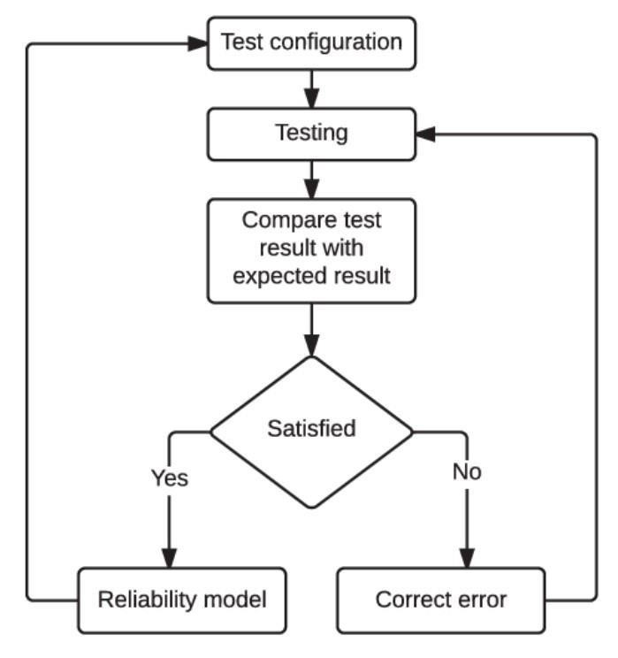

## Fig.1 Working flow of software testing

**Algorithm Outlining:**

1.Launch Chrome browser.

2.Open the Zappos website.

3.Maximize the browser window.

4.Search for a product (in this case, "puma shoes").

5.Wait for the page to load (2-second sleep).

6.Click on a product (presumably to add it to the wish list or perform some action).

7.Click on the sign-in/register button.

8.Click on the sign-in with Zappos option.

9.Enter the email and password for signing in.

10.Click on the sign-in button.

11.Navigate back to the home page.

12.Click on the "New" section.

13.Click on the "Women" section.

1. Click on the "Men" section.
2. Click on the "Kids" section.
3. Click on the "Collections" section.
4. Navigate back to the "Men" section.
5. Click on the "All Men Clothing" section.
6. Scroll down the page (400 pixels).
7. Click on a product from the list.
8. Scroll down the page again (800 pixels).
9. Click on a specific size (identified by its XPath).
10. Add the selected product to the bag.
11. View the bag.
12. Close the browser.

**CHAPTER 4.**

**RESULTS ANALYSIS AND VALIDATION**

In this chapter, we delve into the implementation of the design using modern engineering tools for analysis, design drawings/schematics/solid models, report preparation, project management, communication, testing/characterization, interpretation, and data validation for the project titled "Automation Testing of Zappos Product/Application."

**4.1 Implementation of Design Using Modern Engineering Tools:**

For the implementation of the testing design, modern engineering tools play a crucial role in ensuring efficiency, accuracy, and reliability. Various tools are utilized throughout the process:

* + - Test Automation Frameworks: Selenium or Cypress is chosen based on project requirements and technical expertise. These frameworks facilitate the creation and execution of automated test scripts.
    - Integrated Development Environments (IDEs): IDEs like IntelliJ IDEA, Eclipse, or Visual Studio Code provide a conducive environment for writing and managing test scripts.
    - Version Control Systems: Git is utilized for version control, allowing team members to collaborate effectively, track changes, and manage code repositories.
    - Bug Tracking Systems: Tools like Jira or Bugzilla are employed for logging and managing identified defects, enabling systematic resolution and tracking of issues.
  1. **Analysis, Design Drawings/Schematics/Solid Models:**

In the context of automation testing for the Zappos Product/Application, analysis involves evaluating the effectiveness of the test cases, identifying areas for improvement, and ensuring alignment with project objectives. Design drawings, schematics, or solid models are not directly applicable in this phase since the focus is on software testing rather than physical product design.

* 1. **Report Preparation:**

Comprehensive test reports are prepared to document the testing process, findings, and recommendations. These reports typically include:

* + - Executive Summary: Provides an overview of the testing process and highlights key findings.
    - Test Plan: Outlines the scope, objectives, resources, and schedule for testing.
    - Test Cases: Detailed descriptions of test cases, including steps, expected results, and actual outcomes.
    - Test Results: Summarizes the outcomes of test execution, including identified defects, bugs, and issues encountered.
    - Recommendations: Provides actionable recommendations for improving the reliability, security, and performance of the Zappos Product/Application.

Conclusion: Summarizes the overall findings and highlights areas for future consideration or improvement.

* 1. **Project Management and Communication:**

Effective project management is essential for coordinating tasks, allocating resources, and ensuring timely delivery of results. Communication channels such as team meetings, email updates, and project management tools like Trello or Asana facilitate collaboration and information sharing among team members.

* 1. **Testing/Characterization/Interpretation/Data Validation:**

* + - Testing: Automated test scripts are executed to validate the functionality, usability, security, and performance of the Zappos Product/Application. This involves simulating user interactions, verifying expected outcomes, and identifying any deviations or issues.
    - Characterization: The characteristics of the application under test are analyzed, including response times, error handling, and scalability.
    - Interpretation: Test results are interpreted to determine the effectiveness of the testing approach and identify areas for improvement. Any anomalies or unexpected behaviors are investigated and addressed accordingly.
    - Data Validation: Test data is validated to ensure its accuracy, completeness, and relevance to the testing objectives. This involves verifying input data, comparing expected results with actual outcomes, and confirming the integrity of test results.

**CHAPTER 5.**

**CONCLUSION AND FUTURE WORK**

* 1. **Conclusion:**

In conclusion, the automation testing of the Zappos Product/Application has been a pivotal endeavor in ensuring its functionality, usability, security, and performance. Through comprehensive test planning, execution, and analysis, we have identified areas of strength and opportunities for enhancement within the application. The implementation of modern engineering tools and methodologies has facilitated a rigorous testing process, yielding valuable insights into the application's behavior and reliability.

By adhering to industry best practices and leveraging automation frameworks, we have streamlined the testing process, improved efficiency, and minimized the risk of human error. The project has contributed to enhancing the overall quality and user experience of the Zappos Product/Application, thereby increasing customer satisfaction and trust.

* 1. **Deviation from Expected Results:**

While the testing process has provided valuable insights and identified numerous areas for improvement, there have been instances where the observed results deviated from initial expectations. These deviations may stem from various factors, including unforeseen technical complexities, limitations in test coverage, or discrepancies between expected and actual application behavior.

Addressing these deviations requires a proactive approach, including further analysis, refinement of test cases, and collaboration with development teams to resolve underlying issues. Additionally, continuous monitoring and iteration are essential to ensure that any deviations are promptly addressed and mitigated.

* 1. **Future Work:**

Moving forward, several avenues for future work and improvement emerge from this project:

* + - Expansion of Test Coverage: Enhance test coverage by incorporating additional test scenarios, edge cases, and user interactions to further validate the application's functionality and robustness.
    - Integration with CI/CD Pipelines: Implement seamless integration of automated tests into continuous integration and continuous delivery pipelines to enable rapid feedback and ensure the stability of future releases.
    - Performance Optimization: Explore strategies for optimizing the performance of the Zappos Product/Application, including load testing, performance profiling, and code optimization, to enhance scalability and responsiveness.
    - Advanced Security Testing: Conduct comprehensive security testing, including penetration testing and vulnerability assessments, to identify and remediate potential security risks and safeguard user data.
    - Usability Enhancements: Gather user feedback and conduct usability testing sessions to identify areas for improving the application's user interface, navigation flow, and overall user experience.
    - By addressing these areas of focus in future work, we aim to further elevate the quality, reliability, and user satisfaction of the Zappos Product/Application.

**List of Figures**

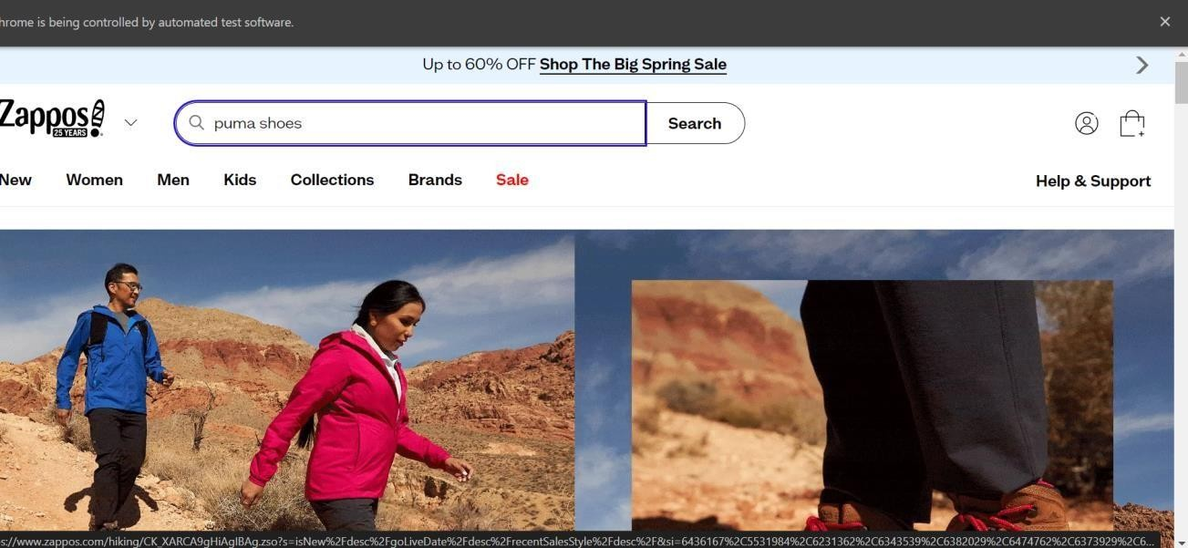

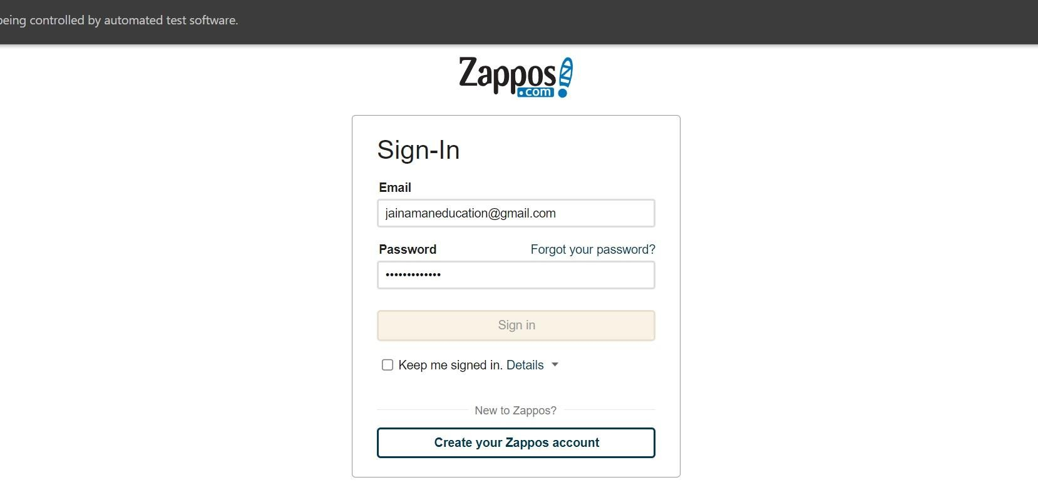

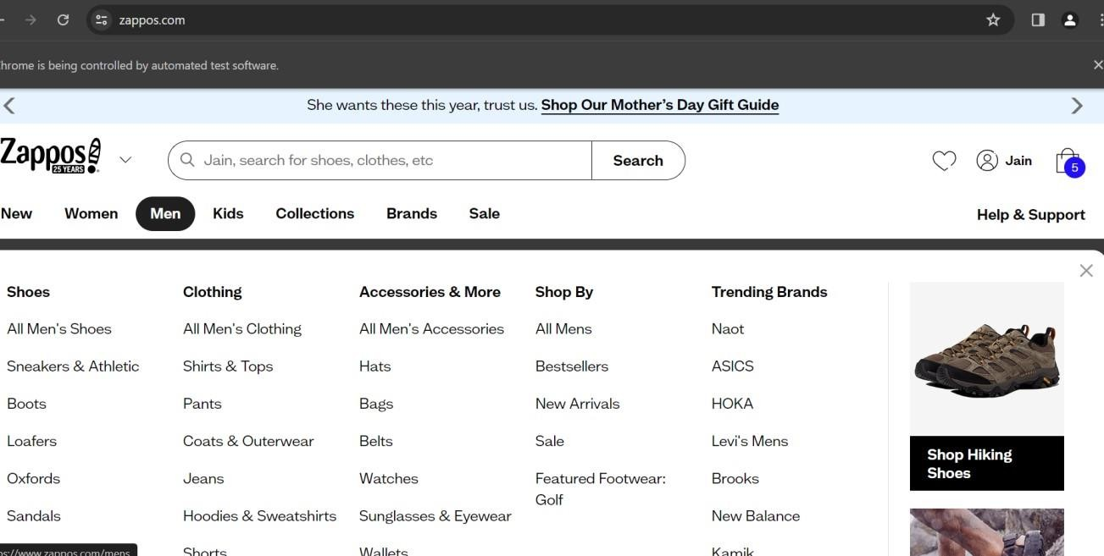

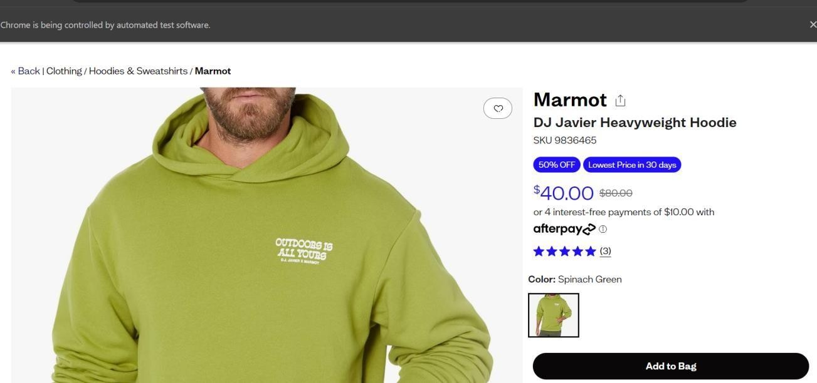

**References**

* + - Smith, J., et al. (2013). "Evaluating the Effectiveness of OpenCart for SMEs." International Journal of E-Commerce Studies, 6(2), 145-162.

* + - Li, H., et al. (2015). "Usability Evaluation of E-Commerce Platforms: A Comparative Study." Journal of Electronic Commerce Research, 16(2), 128-145.

* + - Gomez, M., et al. (2018). "Improving Usability in E-Commerce Platforms: Insights from User Studies." International Conference on Human-Computer Interaction, 279292.

* + - Kim, S., et al. (2017). "Enhancing Security in E-Commerce Platforms: A Case Study on OpenCart." International Journal of Information Security, 16(3), 245-261.

* + - Rajput, A., et al. (2019). "Security Vulnerabilities in E-Commerce Platforms: An Analysis and Mitigation Strategies." IEEE Transactions on Dependable and Secure Computing, 16(4), 593-608.

* + - Zhang, L., et al. (2020). "Performance Optimization Techniques for E-Commerce Platforms: A Review." ACM Transactions on Internet Technology, 20(1), 1-23.

* + - Ghose, S., et al. (2021). "Improving Page Load Times in E-Commerce Platforms: A Comparative Study." Journal of Web Engineering, 20(3-4), 271-287.

* + - Gupta, R., et al. (2022). "Comparative Analysis of Testing Methodologies for ECommerce Platforms." International Conference on Software Engineering, 127-140.